1.INTRODUCTION

Domain Description
Android is a mobile operating system (OS) based on the Linux kernel and currently developed by Google. With a user interface based on direct manipulation, Android is designed primarily for touch screen mobile devices such as smart phones and tablet computers, with specialized user interfaces for televisions (Android TV), cars (Android Auto), and wrist watches (Android Wear). The OS uses touch inputs that loosely correspond to real-world actions, like swiping, tapping, pinching, and reverse pinching to manipulate on-screen objects, and a virtual keyboard. Despite being primarily designed for touch screen input, it also has been used in game consoles, digital cameras, regular PCs (e.g. the HP Slate 21) and other electronics.
As of July 2013, the Google Play store has had over one million Android applications ("apps") published, and over 50 billion applications downloaded. A developer survey conducted in April–May 2013 found that 71% of mobile developers develop for Android. At Google I/O 2014, the company revealed that there were over one billion active monthly Android users, up from 538 million in June 2013. As of 2015, Android has the largest installed base of all general-purpose operating systems.
Android's source code is released by Google under open source licenses, although most Android devices ultimately ship with a combination of open source and proprietary software, including proprietary software developed and licensed by Google. Initially developed by Android, Inc., which Google backed financially and later bought in 2005, Android was unveiled in 2007, along with the founding of the Open Handset Alliance—a consortium of hardware, software, and telecommunication companies devoted to advancing open standards for mobile devices.
Android is popular with technology companies which require a ready-made, low-cost and customizable operating system for high-tech devices. Android's open nature has encouraged a large community of developers and enthusiasts to use the open-source code as a foundation for community-driven projects, which add new
features for advanced users or bring Android to devices which were officially, released running other operating systems. The operating system's success has made it a target for patent litigation as part of the so-called "Smartphone" between technology companies.

Android Versions:
Code name | Version number | Initial release date | API  level | Support status
Alpha | 1.0 | September 23,  2008 | 1 | Unsupported
Beta | 1.1 | February 9, 2009 | 2 | Unsupported
Cupcake | 1.5 | April 27, 2009 | 3 | Unsupported
Donut | 1.6 | September 15,  2009 | 4 | Unsupported
Eclairs | 2.0 - 2.1 | October 26, 2009 | 5 - 7 | Unsupported
Froyo | 2.2 - 2.2.3 | May 20, 2010 | 8 | Unsupported
Gingerbread | 2.3 - 2.3.7 | December 6, 2010 | 9 - 10 | Unsupported
Honeycomb | 3.0 - 3.2.6 | February 22, 2011 | 11 - 13 | Unsupported
Ice Cream Sandwich | 4.0 - 4.0.4 | October 18, 2011 | 14 - 15 | Unsupported

Jelly Bean | 4.1 - 4.3.1 | July 9, 2012 | 16 - 18 | Unsupported
KitKat | 4.4 - 4.4.4 | October 31, 2013 | 19 | Unsupported
Lollipop | 5.0 - 5.1.1 | November 12,  2014 | 21 - 22 | Unsupported
Marshmallow | 6.0 - 6.0.1 | October 5, 2015 | 23 | Supported
Nougat | 7.0 - 7.1.2 | August 22, 2016 | 24 - 25 | Supported
Oreo | 8.0 | TBA | 26 | Supported
Pie
Table 1.1:Android version
Android studio:
Android Studio is the official integrated development environment (IDE) for the Android platform. It was announced on May 16, 2013 at the Google I/O conference. Android Studio is freely available under the Apache License 2.0.
Based on JetBrains' IntelliJ IDEA software, Android Studio is designed specifically for Androiddevelopment. It isavailable for download on Windows, macOS and Linux, and replaced Eclipse Android Development Tools (ADT) as Google's primary IDE for native Android application development.

Android studio versions:
    - Android Studio v3.0 (October 2017)
    - Android Studio v2.2.3 (December 2016)

    - Android Studio v2.2.2 (October 2016)
    - Android Studio v2.2.1 (October 2016)

    - Android Studio v2.2.0 (September 2016)

    - Android Studio v2.1.3 (August 2016)

    - Android Studio v2.1.2 (June 2016)

    - Android Studio v2.1.1 (May 2016)

    - Android Studio v2.1.0 (April 2016)

    - Android Studio v2.0.0 (April 2016)

    - Android Studio v1.5.1 (December 2015)

    - Android Studio v1.5.0 (November 2015)

    - Android Studio v1.4.1 (October 2015)

    - Android Studio v1.4.0 (September 2015)

    - Android Studio v1.3.2 (August 2015)

    - Android Studio v1.3.1 (August 2015)

    - Android Studio v1.3.0 (July 2015)

    - Android Studio v1.2.2 (June 2015)

    - Android Studio v1.2.1 (May 2015)

    - Android Studio v1.2.0 (April 2015)

    - Android Studio v1.1.0 (February 2015)

    - Android Studio v1.0.1 (December 2014)

    - Android Studio v1.0 (December 2014)

    - Android Studio v0.8.14 (October 2014)

    - Android Studio v0.8.6 (August 2014)

    - Android Studio v0.8.0 (June 2014)

    - Android Studio v0.5.2 (May 2014)

    - Android Studio v0.4.6 (March 2014)

    - Android Studio v0.4.2 (Jan 2014)

    - Android Studio v0.3.2 (Oct 2013)

    - Android Studio v0.2.x (July 2013)

    - Android Studio v0.1.x (May 2013)

1.2.About the Project
Doctors Appointment app is useful for booking appointments to consult a doctor without going to hospital. This app will handles the information about Doctor Consultation and Scheduling, Doctor Consultancy Fees and Time Allocation. User can search for the doctors based on their Specialty, Time and Consultancy Fees and can book the appointment. Once the booking is confirmed, then user will get an SMS regarding the confirmation of booking.

2. SYSTEM ANALYSIS

Existing System
Now a days people are getting ill frequently because of current environment. Some of may don’t know which doctor to consult. For that they need to go to hospital and stand in a queue for taking a new OP and wait for their turn in order to consult the doctor. It is a waste of time and Energy. If a person who is in out of city wants to book an appointment then it is a difficult task for him to go to hospital.

Disadvantages of Existing System
    - Standing in a queue for taking new OP.
    - Waiting for your turn to consult a doctor is a waste of time.
    - If we lost the OP then we need to take the new one.

Proposed System
The proposed app is useful for booking appointments to consult a doctor without going to hospital. This app will handles the information about Doctor Consultation and Scheduling, Doctor Consultancy Fees and Time Allocation. User can search for doctor based on their Specialty, Time and Consultancy Fee and can book the appointment. Once the booking is confirmed, then the user will get an SMS regarding the confirmation of booking.

Advantages of Proposed System
- No need of Waiting in a queue for taking new OP.
- If a person is in out of city, he/she can book the appointment easily without going to hospital.
- Can save Time.
- Anyone can book the appointment.
- More flexible and can be accessed if the mobile has internet.
- Can take the Snapshot of OP.

Modules

Register
Every Doctor must get registered in the registration form to move next login page. After login he will get the information list and information about the people who booked appointment at particular time and date. Without entering the details in registration form we cannot move to the infrormation list. It stores doctor details for login purpose.

Login
Every doctor should login into the application to maintain confidentiality and maintain sustainable relationship for information sharing. After completing the registration page only the user can login. User must enter the login correct details as entered in the registration form.

Database
The database used in our application is for storing the data of the registered doctors, for login credentials and patients who are booking appointments. The details can be stored in the form of tables. At the time of doctor login, it will matches the details entered by him/her within the registration details. If the details are matched then he/she can login into the app or otherwise it displays login error.

3. SYSTEM REQUIREMENTS SPECIFICATION

Hardware Requirements

Processor : Pentium 4.0(1.6 GHz) Hard disk : Minimum 512 MB
RAM : 4GB

Software Requirements

Development Requirements

Operating System - Windows 7/810
Coding Language - Java 1.8
Toolkit - Android 3.0
IDE - JetBrains' IntelliJ IDEA
Database - MYSQL
Tools - Emulator, Android device

Server Side Requirements

Database Server - MYSQL SERVER - 000WebHost

Software Description

Emulation refers to the ability of a computer program in an electronic device to emulate (imitate) another program or device. Many printers, for example, are designed to emulate Hewlett-Packard LaserJet printers because so much software is written for HP printers. If a non-HP printer emulates an HP printer, any software written for a real HP printer will also run in the non-HP printer emulation and produce equivalent printing.
A mobile phone is a portable telephone that can make and receive calls over a radio frequency link while the user is moving within a telephone service area. The radio frequency link establishes a connection to the switching systems of a mobile phone operator, which provides access to the public switched telephone network (PSTN). Most modern mobile telephone services use cellular network architecture, and, therefore, mobile telephones are often also called cellular telephones or cell phones. In addition to telephony, 2000s-era mobile phones support a variety of other services, such as text messaging, MMS, and email.

Feasibility Study
All projects are feasible, given unlimited resources and infinite time. But the development of software is plagued by the scarcity of resources and difficult delivery rates. It is both necessary and prudent to evaluate the feasibility of a project at the earliest possible time. Three key considerations are involved in the feasibility analysis.

Economic Feasibility
This procedure is to determine the benefits and savings that are expected from a candidate system and compare them with costs. If benefits outweigh costs, then the decision is made to design and implement the system.
Technical Feasibility
Technical feasibility centers on the existing computer system (hardware, software, etc.,) and to what extent it can support the proposed addition. If the budget is a serious constraint, then the project is judged not feasible.

Operational Feasibility
People are inherently resistant to change, and computers have been known to facilitate change. It is understandable that the introduction of a candidate system requires special effort to educate, sell, and train the staff on new ways of conducting business. As this project is a user friendly version there is not much training required for the people to use.So we say that this product is operationally feasible.

4. SYSTEM DESIGN

System Architecture
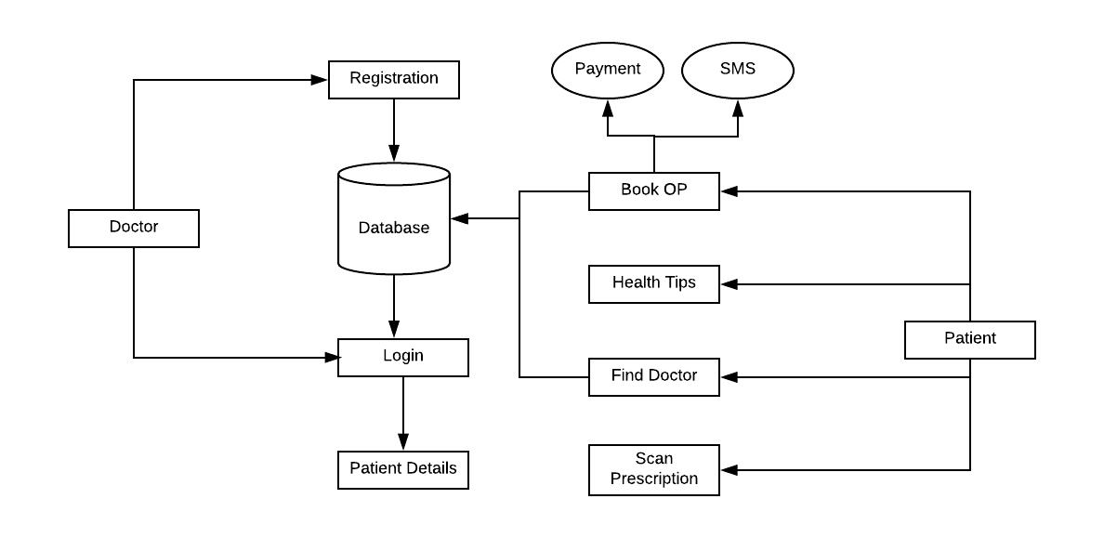
Fig 4.1: Architecture Diagram

Description
Just in mind Prototype is an authoring tool for software prototypes and high- fidelity website wireframes. This architecture consists of database, admin, client and service list first user open the app it shows some services list. Client takes any service from the list that services connected to database. While in that database it fetches all the information available from admin it will be gathered and fetch that information from admin that information send to the client and the client will be seen address of the particular organization service
Introduction To UML
UML is a method for describing the system architecture in detail using the blueprint. UML represents a collection of best engineering practices that have proven successful in the modeling of large and complex systems. The UML is a very important part of developing objects oriented software and the software development process. The UML uses mostly graphical notations to express the design of software
projects. Using the UML helps project teams communicate, explore potential designs, and validate the architectural design of the software.

Definition
UML is a general-purpose visual modeling language that is used to specify, visualize, construct, and document the artifacts of the software system.

UML is a language
It will provide vocabulary and rules for communications and function on conceptual and physical representation. So it is modeling language.

UML Specifying
Specifying means building models that are precise, unambiguous and complete.

UML Visualization
The UML includes both graphical and textual representation. It makes easy to visualize the system and for better understanding.

UML Constructing
UML models can be directly connected to a variety of programming languages and it is sufficiently expressive and free from any ambiguity to permit the direct execution of models.

UML Documenting
UML provides variety of documents in addition raw executable codes.

Goals of UML
The primary goals in the design of the UML were:
    - Provide users with a ready-to-use, expressive visual modeling language so they can develop and exchange meaningful models.
    - Provide extensibility and specialization mechanisms to extend the core concepts.
    - Be independent of particular programming languages and development processes.
    - Provide a formal basis for understanding the modeling language.

Applications of UML
The UML is intended primarily for software intensive systems. It has been used effectively for such domain as
    - Enterprise information systems.

    - Banking and financial services.

    - Telecommunications.

    - Transportation.

Rules of UML
The UML has semantic rules for
    - Names : It will call things, relationships and diagrams.
    - Scope : The content that gives specific meaning to a name.
    - Visibility : How those names can be seen and used by others.
    - Integrity : How things properly and consistently relate to another.
    - Execution : What it means is to run or simulate a dynamic model.

Building Blocks of the UML
The three kinds of building blocks in UML are
- Things.
- Relationships.
- Diagrams.

Uml diagrams
A diagram is graphical representation of a set of elements; most often rendered as a connected graph of vertices a thing. Diagrams in the UML are of 2 types.
    - Static diagrams.
    - Dynamic diagrams.
Static diagrams are:
    - Class diagram.
    - Object diagram.
    - Component diagram.
    - Deployment diagram

Dynamic diagrams are:
    - Use case diagram.
    - Sequence diagram.
    - Collaboration diagram.
    - State chart diagram.
    - Activity diagram.

CLASS DIAGRAM

Aim: To design Class diagram for Doctor Appointment Application.

Problem Description
      - A class is a collection of objects with attributes and operations or methods.
      - An Attribute is a property/characteristic of an entity.
      - Operation is a type of method.
      - Class is a static diagram defines static architecture of model.
      - Class diagram is a structural diagram defines basic architecture of a model.

A class diagram consists of:
      - Classes.
      - Attributes.
      - Operations.
      - Relationships.
      - Association.
      - Aggregation.
      - Generalization.
      - Realization.
      - Multiplicity (or) Cardinality.

Classes:
It contains classes such as
          - User
          - Home
          - Doctor
          - User Checkup
          - User Delete
          - Receive Confirmation
          - Book OP
          - Health Tips
          - Find Doctor
          - Scan Prescription
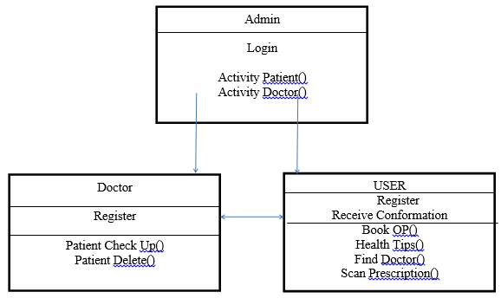 Fig 4.3.1: Class Diagram

4.3.2 USECASE DIAGRAM

Aim: To design Use case diagram for Doctor Appointment Application.

Problem Description
      - It simply understandable diagram of UML.
      - Actor is a major part in Use Case diagram, communicates with the system.
      - Association plays major role between actors & use cases.
      - It is a first diagram of UML gives simplified easy to view of any task.
      - Use case is also a part in use case diagram, gives us utilization of tasks.
      - Use Case diagram developed by Grady Booch,ivar Jacobson & James Rum Bergh.
      - Use Case diagrams consists of:

- Actors.
- Use case.
- Associations (relationships).

Use case:
Use case is a description of set of sequence of actions that a system performs that yields an observable result of value to a particular actor. A use case is used to structure the behavioral things in a model.

Actor:
Actor is the user of the system, who performs action on the system and to whom the system yields an observable result of value.

Actors:

Use cases:
- user
- Admin

It consists of use cases:
  - Registration
  - Login
  - Patient Checkup
  - Call
  - Delete Patient
  - Book Op
  - Find Doctor
  - Health Tips
  - Scan Prescription
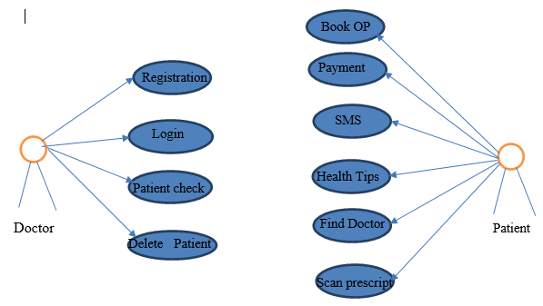
Fig 4.3.2: Use case Diagram

4.3.3 SEQUENCE DIAGRAM

Aim: To design Sequence diagram for SMART INFO TIRUPATI Application.

Problem Description:
Sequence diagram is a interaction diagram i.e. interaction between steps or action. Sequence diagram is a dynamic behavior diagram i.e. including actors, objects and messages.
      - Sequence diagram focuses on time ordering of the objects.
      - Identify actors, objects and messages within system overtime.
      - Interaction diagrams are at their best when the behavior is simple.
      - It shows potential interaction between objects in system, in the order in which they normally occur.
      - A sequence diagram shows as parallel vertical lines, different processes or objects that live simultaneously.
      - Sequence diagram consists of :
        - Actors.
        - Objects.
        - Messages.
        - Lifelines/time lines.
        - Associations.
        - Activation.

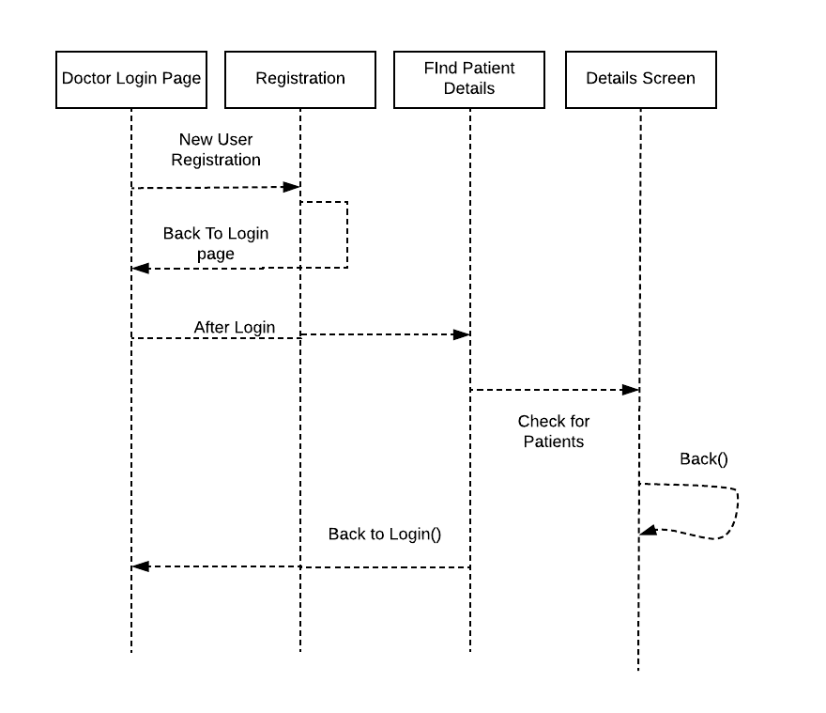
Fig 4.3.3: Sequence diagram

4.3.4CHART STATE DIAGRAM

Aim: To design Collaboration diagram for Doctor Appointment Application.
Problem Description:
      - A State Chart describes about the lifetime of objects and to model lifetime of an object.
      - State Chart is the one of the five diagrams of UML used to model Dynamic model.
      - The State Chart diagram consists of
        - Home.
        - Registration
        - Login.
        - Patient Details
        - Book OP
        - Find Doctor
        - Health Care
        - Scan Prescription

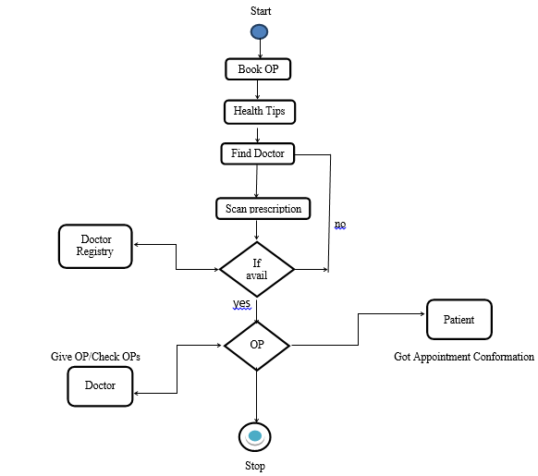
Fig 4.3.4: State Chart Diagram

5. SYSTEM IMPLEMENTATION

5.1SoftwareDescription: Introduction to Java
Java was conceived by James Gosling, Patrick Naughton, Chris Warth, Ed Frank and Mike Sheridan at Sun Microsystems Inc. in 1991. It took 18 months to develop the first working version. This language was initially called “Oak” but was renamed as “Java” in 1995. Between the initial implementation of Oak in the fall of 1992 and the public announcement of Java in the spring of 1995, many more people contributed to the design and evolution of the language.
Somewhat surprisingly, the original impetus for Java was not the Internet! Instead, the primary motivation was the need for a platform-independent language that could be used to create software to be embedded in various consumer electronic devices, such as microwave ovens and remote controls. Java can be used to create two types of programs: applications and applets. An application is a program that runs on your computer, under the operating system of that computer. This is, an application created by java is more or less like one created using C or C++. An applet is an application designed to be transmitted over the Internet and executed by a Java- enabled web browser. An applet is actually a tiny Java program, dynamically downloaded across the network, just like an image, sound file, or video clip.

Features of Java
The main properties of the java, which made java so popular, are as follows:
    - Simple
    - Secure
    - Portable
    - Object-oriented
    - Robust
    - Multithreaded
    - Interpreted

Simple
Java can be learnt and implemented easily by a programmer who is familiar with OOPS. It is the best language that applies Object Oriented technology.

Secure
Java does not allow programs easy unauthorized access to system resources like System Memory and other data.

Object Oriented
Java implements object oriented concepts and design model completely.
Hence it is fully object oriented.

Portable
Java follows the concept of "write once run anywhere" and hence is portable. Programs written in languages in c, c++ in order to get executed need to be compiled. These compilers are specific to a particular platform. A compiler generates an object code of the program, which is binary form. The Linker converts this into a machine executable form.
Java Virtual Machine is not a physical machine but an imaginary one. It emulates virtually a computer system that is the processor, memory and input output devices. It is software, which creates a virtual machine in the memory, and Java compiler compiles the program for this virtual machine. When the program executes the Java interpreter loads the JVM specific to the machine into the memory and the program executes using the JVM.
Robust Java provides a very stable programming environment.

Multithreaded
In a multithreaded environment a number of tasks can be performed at the same time. It is a capability where portions of a program can concurrently run with other portions of the same program.

Interpreted
When a java source code is compiled it generates an intermediate form called byte code .This compiled byte code is interpreted by the JVM. Unlike the executable code generated by other languages which is directly executable the byte code must be interpreted by the JVM before it can be executed. When you open a web page through a browser which is Java enabled (meaning it has JVM implemented) the java applets are interpreted and displayed on the page.

Java’s Magic: The Byte Code
The key that allows Java to solve both the security and the portability problems just described is that the output of a Java compiler is not executable code. Rather, it is Byte code. Byte code is a highly optimized set of instructions designed to be executed by the Java run-time system, which is called the Java.
Virtual Machine (JVM). That is, in its standard form, the JVM is an interpreter for Byte code. This may come as a bit of a surprise. Translating a Java program into Byte code helps makes it much easier to run a program in a wide variety of environments. The reason is straightforward: only the JVM needs to be implemented for each platform. Once the run-time package exists for a given system, any Java Program can run on it. Remember, although the details of the JVM will differ from platform to platform, all interpret the same Java Byte code.

Java Environment:
Java environment includes a large number of development tools and hundreds of classes and methods. The development tools are part of the system known as Java Development Kit (JDK)and the classes and methods are part of the Java Standard Library (JSL), also known as the Application Programming Interface (API).

Java Development Kit:
The Java Development Kit comes with a collection of tools that are used for developing and running Java programs. They include:
- Applet viewer (for viewing Java applets)
- Javac (Java Compiler)
- Java (Java Interpreter)
- Javap (Java Disassembler)
- Javah (for C header files)
- Javadoc (for creating HTML documents)
- Jdb (Java debugger)

Application Program Interface:
The Java Standard Library (or API) includes hundreds of classes and methods grouped into several functional packages. Most commonly used packages are:
- Language Support Package: A collection of classes and methods required for implementing basic features of Java.
- Utilities Package: A collection of classes to provide utility functions such as
date and time functions.
- Input/output Package: A collection of classes required for input/output manipulation.
- Networking Package: A collection of classes for communicating with other computers via Internet.
- AWT Package: The Abstract Window Tool Kit package contains classes that implements platform-independent graphical user interface.
- Applet Package: This includes a set of classes that allows us to create Java
applets.

Data Types:
One of the fundamental concepts of any programming language is that of data types. Data types define the storage methods available for representing information, along with how the information is interpreted. Data types are linked tightly to the storage of variables in memory because the data type of a variable determines how the compiler interprets the contents of the memory. You already have received a little taste of data types in the discussion of literal types.
To create a variable in memory, you must declare it by providing the type of the variable as well as an identifier that uniquely identifies the variable. The syntax of the Java declaration statement for variables follows:
Type Identifier [, Identifier];
Java data types can be divided into two categories: simple and composite. Simple data types are core types that are not derived from any other types. Integer,
floating-point, Boolean, and character types are all simple types. Composite types, on the other hand, are based on simple types, and include strings, arrays, and both classes and interfaces in general. You’ll learn about arrays later in this chapter. Classes and interfaces are covered in Chapter 14, “Classes, Packages, and Interfaces.”

Integer Data Types
Integer data types are used to represent signed integer numbers. There are four integer types: byte, short, int and long. Each of these types takes up a different amount of space in memory, as shown in the below Table.

Java integer types
Type | Size
Byte | 8 bits
Short | 16 bits
Int | 32 bits
Long | 64 bits
To declare variables using the integer types, use the declaration syntax mentioned previously with the desired type. The following are some examples of declaring integer variables:
int i;
short rocketFuel;
long angle, magnitude; byte red, green, blue;

Floating-Point Data Types
Floating-point data types are used to represent numbers with fractional parts. There are two floating-point types: float and double. The float type reserves storage for a 32-bit single-precision number and the double type reserves storage for a 64-bit double-precision number.
Declaring floating-point variables is very similar to declaring integer variables.
The following are some examples of floating-point variable declarations:
float temperature;
double windSpeed, barometricPressure;

Boolean Data Type
The Boolean data type is used to store values with one of two states: true or false. You can think of the Boolean type as a 1-bit integer value, because 1 bit can have only two possible values: 1 or 0. However, instead of using 1 and 0, you use the Java keywords true and false. True and false aren’t just conveniences in Java; they are actually the only legal Boolean values. This means that you can’t interchangeably use Booleans and integers like in C/C++. To declare a Boolean value, just use the Boolean type declaration.

Character Data Type
The character data type is used to store single Unicode characters. Because the Unicode character set is composed of 16-bit values, the char data type is stored as a 16-bit unsigned integer. You create variables of type char as follows:
char firstInitial, lastInitial;
Remember that the char type is useful only for storing single characters. If you come from a C/C++ background, you might be tempted to try to fashion a string by creating an array of chars.

Interface:
Unlike other normal classes, an interface contains only abstract methods and final variables. This implies that there is no executable code in these methods and data fields can only constitute of constants. To use the features of interfaces we need to implement the interface.
When a class implements an interface, it is here where the code for implementation of the abstract methods in the interface will be given. The concept of the multiple inheritance is thus achieved to some extent by Interfaces i.e. a programmer will be able to access the variables and functions of different interfaces in his class. An interface will be defined using the interface keyword.
The name of the interface can be any valid Java identifier similar to class names.
interface <interface name>{ Declaration of variables; Declaration of methods;}
Return-type<method name> (parameter list);

All the variables and the methods declared in the interface become
public implicitly if the interface is declared as public.

XML
Extensible Markup Language (XML) is the predominant markup language for web pages. XML is designed to transport and store the data.XML is important to know, and very easy to learn. XML tags are not predefined. You must define your own tags. XML is defined to be self-descriptive. With XML data can be stored in separate XML files. This way you can concentrate on using HTML/CSS for display and layout, and be sure that changes in the underlying data will not require any changes to the XML.
This makes it much easier to create data that can be shared by different applications. Exchanging data as XML greatly reduces this complexity. Since the data can be read by different incompatible applications.
XML data is stored in Text format. This makes it easier to expand or upgrade to new operating system, new applications, or new browsers without losing the data.

Introduction to Android
Android is an open source and Linux-based Operating System for mobile devices such as smart phones and tablet computers. Android was developed by the Open Handset Alliance, led by Google, and other companies.
Android offers a unified approach to application development for mobile devices which means developers need only develop for Android, and their applications should be able to run on different devices powered by Android. The first beta version of the Android Software Development Kit (SDK) was released by Google in 2007 where as the first commercial version, Android 1.0, was released in September 2008.
On June 27, 2012, at the Google I/O conference, Google announced the next Android version, 4.1 Jelly Bean. Jelly Bean is an incremental update, with the primary aim of improving the user interface, both in terms of functionality and performance.
The source code for Android is available under free and open source software licenses. Google publishes most of the code under the Apache License version 2.0 and the rest, Linux kernel changes, under the GNU General Public License version 2

Android Environment Setup
You will be glad to know that you can start your Android application development on either of the following operating systems:
  - Microsoft Windows XP or later version.
  - Mac OS X 10.5.8 or later version with Intel chip.
  - Linux including GNU C Library 2.7 or later.

Second point is that all the required tools to develop Android applications are freely available and can be downloaded from the Web.
Following is the list of software's you will need before you start your Android application programming.
  - Java JDK5 or JDK6
  - Android SDK
  - Eclipse IDE for Java Developers (optional)
  - Android Development Tools (ADT) Eclipse Plug-in (optional)

Here last two components are optional and if you are working on Windows machine then these components make your life easy while doing Java based application development. So let us have a look how to proceed to set required environment.
Step 1 - System Requirements
You will be delighted, to know that you can start your Android application
development on either of the following operating systems −
- Microsoft® Windows® 10/8/7/Vista/2003 (32 or 64-bit)
- Mac® OS X® 10.8.5 or higher, up to 10.9 (Mavericks)
- GNOME or KDE desktop
Second point is that all the required tools to develop Android applications are open source and can be downloaded from the Web. Following is the list of software's you will need before you start your Android application programming.
- Java JDK5 or later version
- Java Runtime Environment (JRE) 6
- Android Studio

Step 2 - Setup Android Studio

Overview
Android Studio is the official IDE for android application development. It works based on IntelliJ IDEA, You can download the latest version of android studio from Android Studio 2.2 Download, If you are new to installing Android Studio on windows, you will find a file, which is named as android-studio-bundle-
143.3101438-windows.exe.So just download and run on windows machine according to android studio wizard guideline.
If you are installing Android Studio on Mac or Linux, You can download the latest version from Download, or Android Studio Linux Download, check the instructions provided along with the downloaded file for Mac OS and Linux. This tutorial will consider that you are going to setup your environment on Windows machine having Windows 8.1 operating system.

Installation:
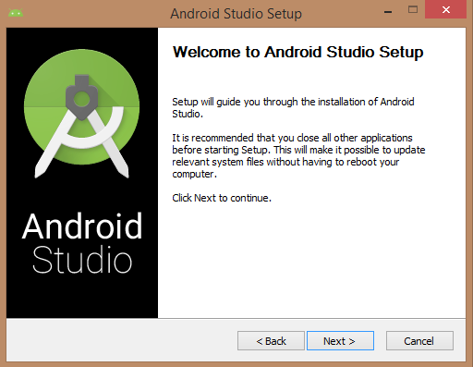
So let's launch Android Studio.exe,Make sure before launch Android Studio, Our Machine should required installed Java JDK. To install Java JDK,take a references of Android environment setup
Fig: 5.1 Android setup
Once you launched Android Studio, it’s time to mention JDK7 path or later version in android studio installer.
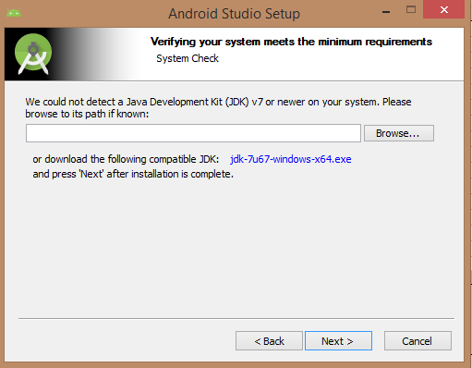
Fig: 5.2 JDK setup
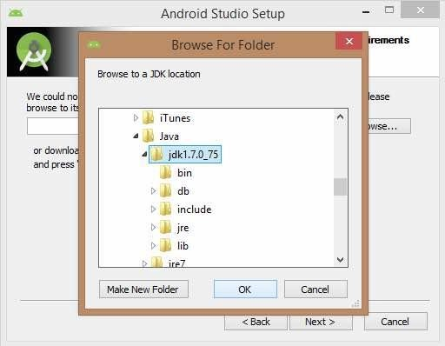
Below the image initiating JDK to android SDK
Fig: 5.3 Set JDK PATH
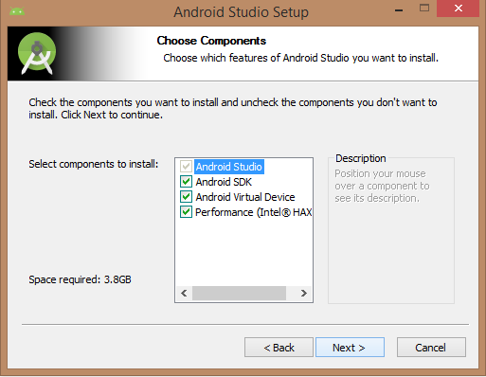
Need to check the components, which are required to create applications, below the image have selected Android Studio, Android SDK, Android Virtual Machine and performance (Intel chip).

Fig: 5.4 Android setup install
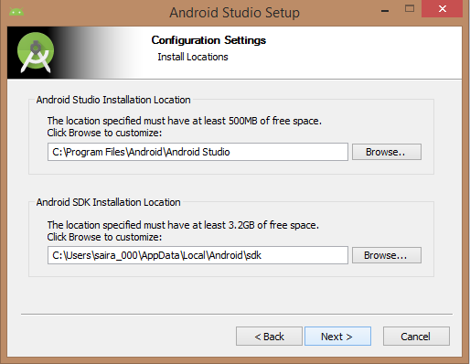
Need to specify the location of local machine path for Android studio and Android SDK, below the image has taken default location of windows 8.1 x64 bit architecture.

Fig: 5.5 Android SDK path

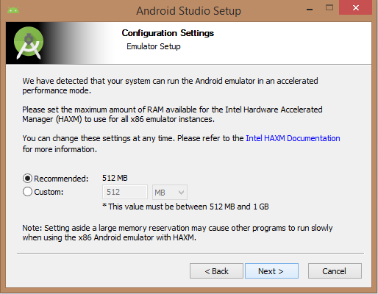
Need to specify the ram space for Android emulator by default it would take 512MB of local machine RAM.
Fig: 5.6 Emulator setup
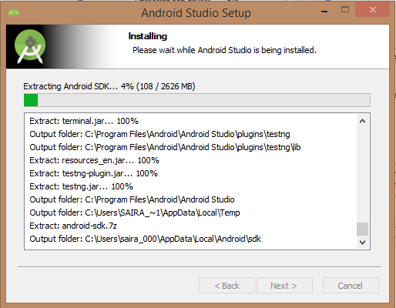
At final stage, it would extract SDK packages into our local machine, it would take a while time to finish the task and would take 2626MB of Hard disk space.
Fig: 5.7 Install process
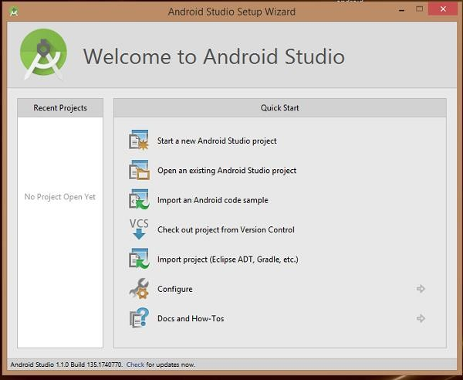
After done all above steps perfectly, you must get finish button and it gonna be open android studio project with Welcome to android studio message as shown below
Fig: 5.8 Android homepage
You can start your application development by calling start a new android studio project. In a new installation frame should ask Application name, package information and location of the project.
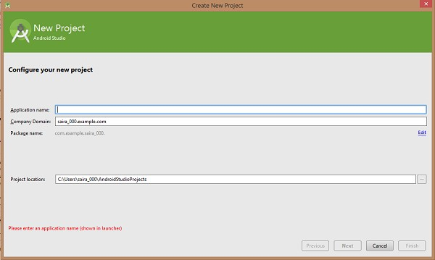
Fig 5.8.1. New projects
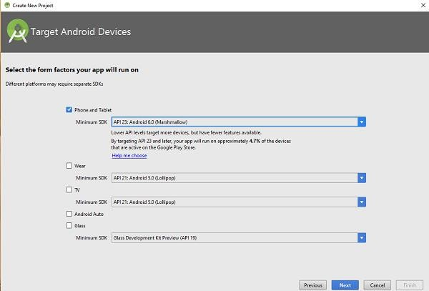
After entered application name, it going to be called select the form factors your application runs on, here need to specify Minimum SDK, in our tutorial, I have declared as API23: Android 6.0(Marshmallow).
Fig: 5.9 Select API

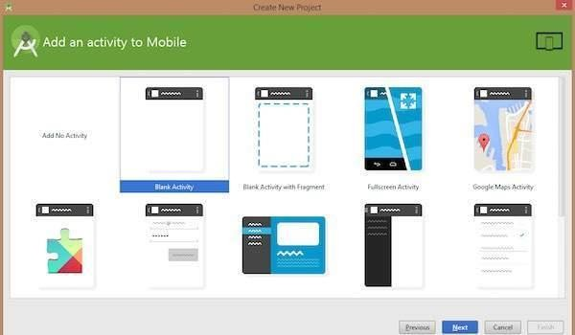
The next level of installation should contain selecting the activity to mobile, it specifies the default layout for Applications
Fig: 5.10 select activity
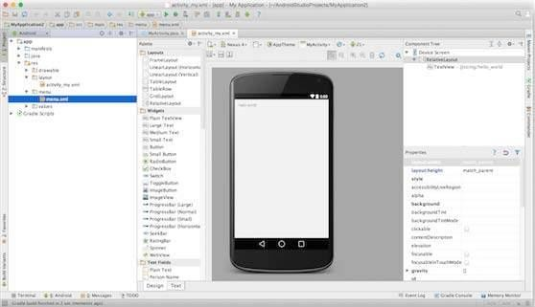
At the final stage it going to be open development tool to write the application code.
Fig: 5.11 design screen

Step 3 - Create Android Virtual Device
To test your Android applications, you will need a virtual Android device. So before we start writing our code, let us create an Android virtual device. Launch Android AVD Manager Clicking AVD_Manager icon as shown below
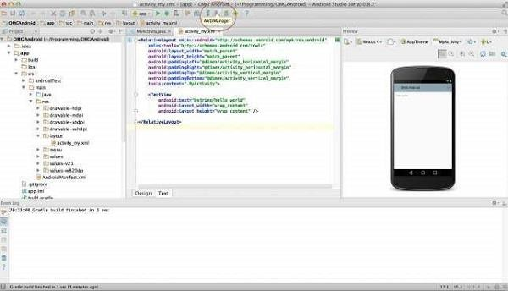
Fig: 5.12 AVD manager
After Click on a virtual device icon, it going to be shown by default virtual devices which are present on your SDK, or else need to create a virtual device by clicking Create new Virtual device button
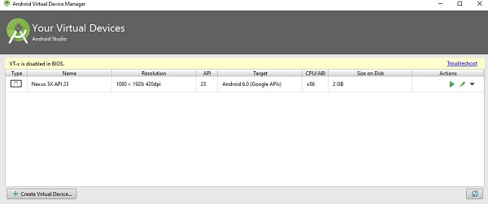
Fig: 5.13 Virtual devices
If your AVD is created successfully it means your environment is ready for Android application development. If you like, you can close this window using top-right cross button. Better you re-start your machine and once you are done with this last step, you are ready to proceed for your first Android example but before that we will see few more important concepts related to Android Application Development.

Hello Word Example
Before Writing a Hello word code, you must know about XML tags. To write hello word code, you should redirect to App>res>layout>Activity_main.xml. To show hello word, we need to call text view with layout ( about text view and layout, you must take references at Relative Layout and Text View ).
<RelativeLayoutxmlns:android="http://schemas.android.com/apk/res/android"
xmlns:tools="http://schemas.android.com/tools"android:layout_width="match_parent"
android:layout_height="match_parent"android:paddingLeft="@dimen/activity_horizo ntal_margin"
android:paddingRight="@dimen/activity_horizontal_margin" android:paddingTop="@dimen/activity_vertical_margin"
android:paddingBottom="@dimen/activity_vertical_margin"tools:context=".MainActi vity">

<TextViewandroid:text="@string/hello_world" android:layout_width="550dp" android:layout_height="wrap_content"/>
</RelativeLayout>

Need to run the program by clicking Run>Run App or else need to call shift+f10
key. Finally, result should be placed at Virtual devices as shown below

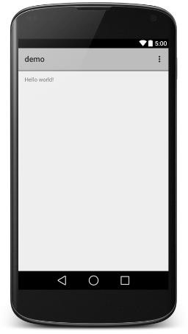
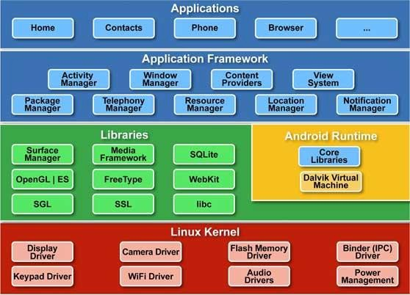
Fig: 5.14 Emulator

Fig. 5.15 Android Architecture

Android Architecture
Android operating system is a stack of software components which is roughly divided into five sections and four main layers as shown below in the architecture diagram.
Linux kernel
At the bottom of the layers is Linux - Linux 2.6 with approximately 115 patches. This provides basic system functionality like process management, memory management, device management like camera, keypad, display etc. Also, the kernel handles all the things that Linux is really good at such as networking and a vast array of device drivers, which take the pain out of interfacing to peripheral hardware.

Libraries
On top of Linux kernel there is a set of libraries including open-source Web browser engine WebKit, well known library libc, SQLite database which is a useful repository for storage and sharing of application data, libraries to play and record audio and video, SSL libraries responsible for Internet security etc.

Android Runtime
This is the third section of the architecture and available on the second layer from the bottom. This section provides a key component called Dalvik Virtual Machine which is a kind of Java Virtual Machine specially designed and optimized for Android.
The Dalvik VM makes use of Linux core features like memory management and multi-threading, which is intrinsic in the Java language. The Dalvik VM enables every Android application to run in its own process, with its own instance of the Dalvik virtual machine.
The Android runtime also provides a set of core libraries which enable Android application developers to write Android applications using standard Java programming language.

Application Framework
The Application Framework layer provides many higher-level services to applications in the form of Java classes. Application developers are allowed to make use of these services in their applications.

Applications
You will find all the Android application at the top layer. You will write your application to be installed on this layer only. Examples of such applications are Contacts Books, Browser, Games etc.

DATABASE DESCRIPTION

INTRODUCTION TO 000WebHost:
000WebHost is a company that offers webhosting services to users. It was started way back in 2006,it has proven to be a leader in the webhosting industry to remain among the 000WebHost was starting with the aim of offering client free web hosting services as opposed to competitors, on top of that, through the services are free, it looks to ensure that the services offered to clients are of high quality. This is how the company has been able to remain among the leaders in the industry since 2006, by manipulating free and quality hosting services.

000WebHost Features:
some of the features that 000webhost offers includethe150MB disk space that users can access, along with a bandwidth 100GB on a monthly basis,More users on 000webhost can be various programming languages such as MySQL,website builder,php My-admin and PHP.000webhost allows users to be able to host their own domain names they offer.

MySQL:
Every web application, howsoever simple or complicated, requires a database for storing collected data. MySQL, which is open source, is the world’s most popular database management system. It powers everything from hobbyist websites to professional platforms like WordPress. You can learn how to master PHP with this free MySQL database for beginners course.

PHP:
PHP stands for Hypertext Preprocessor. It is a server-side scripting language that powers some of the most popular websites in the world, including WordPress and Facebook. It is open source, relatively easy to learn, and works perfectly with MySQL, making it a popular choice for web developers.
  - Sample Code PATIENT HOME Java File:

Public class PatientHome extends AppCompatActivity implements BaseSliderView.OnSliderClickListener, ViewPagerEx.OnPageChangeListener

{

HashMap<String, Integer> Hash_file_maps ;

SliderLayout sliderLayout;

@Override

protected void onCreate(Bundle savedInstanceState) {

super.onCreate(savedInstanceState);

setContentView(R.layout.activity_patient_home);

sliderLayout = (SliderLayout)findViewById(R.id.slider);

Hash_file_maps = new HashMap<String, Integer>();

Hash_file_maps.put("Doctors-The Saviour of lives ",R.drawable.doctors);

Hash_file_maps.put("Medicines",R.drawable.medicines);

Hash_file_maps.put("Medical Shop", R.drawable.medicalshop);

Hash_file_maps.put("Operation Theatre", R.drawable.operationtheatre);

Hash_file_maps.put("Patients Waiting for their turn", R.drawable.waiting);

Hash_file_maps.put("Doctor Checking Patient", R.drawable.patientcheck);

// Hash_file_maps.put("Siemens Soft Launch at Jawaharlal Nehru Technological University, Kakinada",R.drawable.sdc5);

Hash_file_maps.put("Reception",R.drawable.receptionists);

for(String name : Hash_file_maps.keySet()){

TextSliderView textSliderView = new TextSliderView(this);

textSliderView

.description(name)

.image(Hash_file_maps.get(name))

.setScaleType(BaseSliderView.ScaleType.Fit)

.setOnSliderClickListener(this);

textSliderView.bundle(new Bundle());

textSliderView.getBundle()

.putString("extra",name);

sliderLayout.addSlider(textSliderView);

}

sliderLayout.setPresetTransformer(SliderLayout.Transformer.Accordion);

sliderLayout.setPresetIndicator(SliderLayout.PresetIndicators.Center_Bottom);

sliderLayout.setCustomAnimation(new DescriptionAnimation());

sliderLayout.setDuration(3000);

sliderLayout.addOnPageChangeListener(this);

}

public void card_bookOp(View view)

{

Intent intent= new Intent(this, MainActivity.class);

startActivity(intent);

}

public void card_finddoctor(View view)

{

Intent intent= new Intent(this, FindDoctor.class);

startActivity(intent);

}

public void card_prescription(View view)

{

Intent intent= new Intent(this, HealthTips.class);

startActivity(intent);

}

@Override

public void onSliderClick(BaseSliderView slider) {

}

@Override

public void onPageScrolled(int position, float positionOffset, int positionOffsetPixels) {

}

@Override

public void onPageSelected(int position) {

}

@Override

public void onPageScrollStateChanged(int state) {

}

@Override

public boolean onCreateOptionsMenu(Menu menu)

{

getMenuInflater().inflate(R.menu.options,menu);

return super.onCreateOptionsMenu(menu);

}

@Override

public boolean onOptionsItemSelected(MenuItem item)

{

switch (item.getItemId())

{

case R.id.doctor_log:

Intent intent= new Intent(this, DoctorLogin.class);

startActivity(intent);

}

return super.onOptionsItemSelected(item);

}

public void card_scan(View view)

{

Intent intent= new Intent(this,Prescription.class);

startActivity(intent);

}

@Override

public void onBackPressed() {

AlertDialog.Builder dialog= new AlertDialog.Builder(this);

dialog.setTitle("Do you want to close??");

dialog.setPositiveButton("Yes", new DialogInterface.OnClickListener() {

@Override

public void onClick(DialogInterface dialog, int which) {

finish();

}

});

dialog.setNegativeButton("No", new DialogInterface.OnClickListener() {

@Override

public void onClick(DialogInterface dialog, int which) {

dialog.dismiss();

}

});

dialog.show();

}

}

PATIENT HOME XML:
<ScrollView xmlns:android="http://schemas.android.com/apk/res/android"
android:layout_width="match_parent"
android:layout_height="match_parent">
<LinearLayout xmlns:android="http://schemas.android.com/apk/res/android"
xmlns:app="http://schemas.android.com/apk/res-auto"
xmlns:tools="http://schemas.android.com/tools"
android:id="@+id/container"
android:layout_width="match_parent"
android:layout_height="match_parent"
android:orientation="vertical">
<LinearLayout
android:layout_width="match_parent"
android:layout_height="wrap_content"
android:orientation="vertical"
android:paddingBottom="4dp"
android:paddingLeft="8dp"
android:paddingRight="8dp"
android:paddingTop="8dp">
<com.daimajia.slider.library.SliderLayout
android:id="@+id/slider"
android:layout_width="fill_parent"
android:layout_height="200dp" />
</LinearLayout>
<LinearLayout
android:layout_width="match_parent"
android:layout_height="wrap_content"
android:layout_marginTop="25dp"
android:orientation="horizontal">
<android.support.v7.widget.CardView
android:id="@+id/card_bookOp"
android:layout_width="fill_parent"
android:layout_height="130dp"
android:layout_margin="8dp"
android:layout_weight="0.5"
android:clickable="true"
android:elevation="10dp"
android:foreground="?android:attr/selectableItemBackground"
android:foregroundGravity="center"
android:onClick="card_bookOp"
app:cardCornerRadius="15dp">
<LinearLayout
android:layout_width="match_parent"
android:layout_height="wrap_content"
android:layout_gravity="center"
android:gravity="center"
android:orientation="vertical">
<ImageView
android:id="@+id/image"
android:layout_width="80dp"
android:layout_height="80dp"
android:layout_centerHorizontal="true"
android:layout_gravity="center"
android:layout_marginTop="10dp"
android:foregroundGravity="center"
android:scaleType="fitXY"
android:src="@drawable/patient" />
<View
android:layout_width="match_parent"
android:layout_height="1dp"
android:layout_marginTop="8dp" />
<TextView
android:layout_width="match_parent"
android:layout_height="wrap_content"
android:layout_gravity="bottom"
android:layout_marginTop="7dp"
android:gravity="center"
android:text="@string/book"
android:textAppearance="?android:textAppearanceLarge"
android:textColor="@android:color/black"
android:textSize="18sp" />
</LinearLayout>
</android.support.v7.widget.CardView>
<android.support.v7.widget.CardView
android:id="@+id/card_prescription"
android:layout_width="fill_parent"
android:layout_height="130dp"
android:layout_margin="8dp"
android:layout_weight="0.5"
android:clickable="true"
android:elevation="10dp"
android:foreground="?android:attr/selectableItemBackground"
android:foregroundGravity="center"
android:onClick="card_prescription"
app:cardCornerRadius="15dp">
<LinearLayout
android:layout_width="match_parent"
android:layout_height="wrap_content"
android:layout_gravity="center"
android:gravity="center"
android:orientation="vertical">
<ImageView
android:id="@+id/image1"
android:layout_width="80dp"
android:layout_height="80dp"
android:layout_centerHorizontal="true"
android:layout_gravity="center"
android:layout_marginTop="10dp"
android:foregroundGravity="center"
android:scaleType="fitXY"
android:src="@drawable/priscription<View
android:layout_width="match_parent"
android:layout_height="1dp"
android:layout_marginTop="8dp" />
<TextView
android:layout_width="match_parent"
android:layout_height="wrap_content"
android:layout_gravity="bottom"
android:layout_marginTop="8dp"
android:gravity="center"
android:text="Healh Tips"
android:textAppearance="?android:textAppearanceLarge"
android:textColor="@android:color/black"
android:textSize="18sp" />
</LinearLayout>
</android.support.v7.widget.CardView>
</LinearLayout>
<LinearLayout
android:layout_width="match_parent"
android:layout_height="wrap_content"
android:layout_marginTop="0dp"
android:orientation="horizontal">
<android.support.v7.widget.CardView
android:id="@+id/card_finddoctor"
android:layout_width="fill_parent"
android:layout_height="130dp"
android:layout_margin="8dp"
android:layout_weight="0.5"
android:clickable="true"
android:elevation="10dp"
android:foreground="?android:attr/selectableItemBackground"
android:foregroundGravity="center"
android:onClick="card_finddoctor"
app:cardCornerRadius="15dp">
<LinearLayout
android:layout_width="match_parent"
android:layout_height="wrap_content"
android:layout_gravity="center"
android:gravity="center"
android:orientation="vertical">
<ImageView
android:id="@+id/image3"
android:layout_width="80dp"
android:layout_height="80dp"
android:layout_centerHorizontal="true"
android:layout_gravity="center"
android:layout_marginTop="10dp"
android:foregroundGravity="center"
android:scaleType="fitXY"
android:src="@drawable/doctoricon2" />
<View
android:layout_width="match_parent"
android:layout_height="1dp"
android:layout_marginTop="8dp" />
<TextView
android:layout_width="match_parent"
android:layout_height="wrap_content"
android:layout_gravity="bottom"
android:layout_marginTop="8dp"
android:gravity="center"
android:text="Find Doctor"
android:textAppearance="?android:textAppearanceLarge"
android:textColor="@android:color/black"
android:textSize="18sp" />
</LinearLayout>
</android.support.v7.widget.CardView>
<android.support.v7.widget.CardView
android:id="@+id/card_scan"
android:layout_width="fill_parent"
android:layout_height="130dp"
android:layout_margin="8dp"
android:layout_weight="0.5"
android:clickable="true"
android:elevation="10dp"
android:foreground="?android:attr/selectableItemBackground"
android:foregroundGravity="center"
android:onClick="card_scan"
app:cardCornerRadius="15dp">
<LinearLayout
android:layout_width="match_parent"
android:layout_height="wrap_content"
android:layout_gravity="center"
android:gravity="center"
android:orientation="vertical">
<ImageView
android:id="@+id/image4"
android:layout_width="80dp"
android:layout_height="80dp"
android:layout_centerHorizontal="true"
android:layout_gravity="center"
android:layout_marginTop="10dp"
android:foregroundGravity="center"
android:scaleType="fitXY"
android:src="@drawable/scan" />
<View
android:layout_width="match_parent"
android:layout_height="1dp"
android:layout_marginTop="8dp" />
<TextView
android:layout_width="match_parent"
android:layout_height="wrap_content"
android:layout_gravity="bottom"
android:layout_marginBottom="4dp"
android:layout_marginTop="8dp"
android:gravity="center"
android:text="Scan Prescription"
android:textAppearance="?android:textAppearanceLarge"
android:textColor="@android:color/black"
android:textSize="18sp" />
</LinearLayout>
</android.support.v7.widget.CardView>
</LinearLayout>
</LinearLayout>
</ScrollView>

DOCTOR LOGIN CLASS:
public class DoctorLogin extends AppCompatActivity
{
EditText docName,docPwd;
TextView reg;
String doct_name,doct_pwd,doct_hosp,doct_spec;
Spinner log_hosp,log_specality;
private static final String EMAIL_PATTERN = "^[a-zA-Z0-9#_~!$&'()*+,;=:.\"(),:;<>@\\[\\]\\\\]+@[a-zA-Z0-9-]+(\\.[a-zA-Z0-9-]+)*$";
private Pattern pattern = Pattern.compile(EMAIL_PATTERN);
private Matcher matcher;
int pos;
ArrayAdapter hospitallistadapter;
@Override
protected void onCreate(Bundle savedInstanceState) {
super.onCreate(savedInstanceState);
setContentView(R.layout.activity_doctor_login);
docName=findViewById(R.id.username);
docPwd=findViewById(R.id.password);
reg=findViewById(R.id.register_here);
log_hosp=findViewById(R.id.login_hosp);
log_specality=findViewById(R.id.login_specality);
log_specality.setOnItemSelectedListener(new AdapterView.OnItemSelectedListener() {
@Override
public void onItemSelected(AdapterView<?> parent, View view, int position, long id)
{
pos=position;
add();
}
@Override
public void onNothingSelected(AdapterView<?> parent) {
}
});
}
public void add()
{
switch (pos)
{
case 1:
hospitallistadapter=new ArrayAdapter(this,R.layout.support_simple_spinner_dropdown_item,getResources().getStringArray(R.array.childrenshospital));
log_hosp.setAdapter(hospitallistadapter);
break;
case 2:
hospitallistadapter=new ArrayAdapter(this,R.layout.support_simple_spinner_dropdown_item,getResources().getStringArray(R.array.eyehospitals));
log_hosp.setAdapter(hospitallistadapter);
break;
case 3:
hospitallistadapter=new ArrayAdapter(this,R.layout.support_simple_spinner_dropdown_item,getResources().getStringArray(R.array.nursinghomes));
log_hosp.setAdapter(hospitallistadapter);
break;
}
}
public void login(View view)
{
doct_name=docName.getText().toString();
doct_pwd=docPwd.getText().toString();
doct_hosp=log_hosp.getSelectedItem().toString();
doct_spec=log_specality.getSelectedItem().toString();
if (doct_name.equals("") || doct_pwd.equals("") || doct_hosp.equals("")||doct_spec.equals(""))
{
Toast.makeText(this, "Please fill the details", Toast.LENGTH_SHORT).show();
}
else if (!validateEmail(doct_name)) {
Toast.makeText(this, "Please Enter Valid Mail id", Toast.LENGTH_SHORT).show();
}
DoctorLoginTask task= new DoctorLoginTask(this);
task.execute(doct_name,doct_pwd,doct_spec,doct_hosp);
docName.setText("");
docPwd.setText("");
log_specality.setSelection(0);
log_specality.setSelection(0);
}
public void openRegister(View view)
{
Intent intent= new Intent(this,DoctorRegistration.class);
startActivity(intent);
}
public boolean validateEmail(String email) {
matcher = pattern.matcher(email);
return matcher.matches();
}
}

DOCTOR LOGIN XML:
public class DoctorLoginTask extends AsyncTask<String,Void,String>
{
Context ctx;
ProgressDialog progress;
private String email,password,hospital,specality;
String result;
public DoctorLoginTask(DoctorLogin doctorLogin)
{
ctx=doctorLogin;
}
@Override
protected void onPreExecute() {
super.onPreExecute();
progress= new ProgressDialog(ctx);
progress.setTitle("Logging user");
progress.setMessage("Loading..plz wait");
progress.setCancelable(false);
progress.show();
}
@Override
protected String doInBackground(String... params)
{
String login_url = "https://uvthegrea8.000webhostapp.com/DoctorAppointment/doctorlogin.php";
email = params[0];
password = params[1];
specality=params[2];
hospital=params[3];
try {
URL url = new URL(login_url);
HttpURLConnection httpURLConnection = (HttpURLConnection) url.openConnection();
httpURLConnection.setRequestMethod("POST");
httpURLConnection.setDoOutput(true);
httpURLConnection.setDoInput(true);
OutputStream outputStream = httpURLConnection.getOutputStream();
BufferedWriter bufferedWriter = new BufferedWriter(new OutputStreamWriter(outputStream, "UTF-8"));
String post_data =
URLEncoder.encode("email", "UTF-8") + "=" + URLEncoder.encode(email,
"UTF-8") + "&"
+ URLEncoder.encode("password", "UTF-8") + "=" + URLEncoder.encode(password, "UTF-8")+"&"
+ URLEncoder.encode("specality", "UTF-8") + "=" + URLEncoder.encode(specality, "UTF-8")+"&"
+ URLEncoder.encode("hospital", "UTF-8") + "=" + URLEncoder.encode(hospital, "UTF-8");
bufferedWriter.write(post_data);
bufferedWriter.flush();
bufferedWriter.close();
outputStream.close();
InputStream inputStream = httpURLConnection.getInputStream();
BufferedReader bufferedReader = new BufferedReader(new InputStreamReader(inputStream, "iso-8859-1"));
String line = "";
while ((line = bufferedReader.readLine()) != null) {
result = line;
}
bufferedReader.close();
inputStream.close();
httpURLConnection.disconnect();
return result;
} catch (Exception e) {
e.printStackTrace();
}
return null;
}
@Override
protected void onPostExecute(String s) {
super.onPostExecute(s);
Toast.makeText(ctx,"The Result is:"+s,Toast.LENGTH_SHORT).show();
Log.d("Login",result);
if (s.equalsIgnoreCase("Login Successfull"))
{
Intent intent= new Intent(ctx,DoctorHome.class);
intent.putExtra("speciality",specality);
intent.putExtra("hospital",hospital);
ctx.startActivity(intent);
}
else {
Toast.makeText(ctx, "Cant login now...", Toast.LENGTH_SHORT).show();
}
/*Intent intent= new Intent(ctx,DoctorHome.class);
intent.putExtra("speciality",specality);
intent.putExtra("hospital",hospital);
ctx.startActivity(intent);*/
progress.dismiss();
}
}
DOCTOR LOGIN XML:

<?xml version="1.0" encoding="utf-8"?>
<RelativeLayout xmlns:android="http://schemas.android.com/apk/res/android"
android:layout_width="match_parent"
android:layout_height="match_parent"
android:orientation="vertical"
android:scrollbarAlwaysDrawVerticalTrack="true">
<RelativeLayout
android:layout_width="fill_parent"
android:layout_height="wrap_content"
android:layout_marginLeft="30dp"
android:layout_marginRight="30dp"
android:layout_marginTop="100dp"
android:background="#fff"
android:elevation="4dp"
android:orientation="vertical"
android:padding="20dp">
<LinearLayout
android:layout_width="fill_parent"
android:layout_height="wrap_content"
android:orientation="vertical"
android:paddingTop="30dp">
<android.support.design.widget.TextInputLayout
android:layout_width="match_parent"
android:layout_height="wrap_content"
>
<EditText
android:id="@+id/username"
android:layout_width="match_parent"
android:layout_height="wrap_content"
android:inputType="textEmailAddress"
android:layout_marginTop="10dp"
android:hint="Enter Username"/>
</android.support.design.widget.TextInputLayout>
<android.support.design.widget.TextInputLayout
android:layout_width="match_parent"
android:layout_height="wrap_content"
android:layout_marginBottom="8dp">
<EditText android:id="@+id/password"
android:layout_width="match_parent"
android:layout_height="wrap_content"
android:layout_marginTop="10dp"
android:inputType="textPassword"
android:hint="Enter Password" />
</android.support.design.widget.TextInputLayout>
<Spinner
android:layout_width="match_parent"
android:layout_height="wrap_content"
android:id="@+id/login_specality"
android:entries="@array/problemType"
android:layout_marginTop="10dp">
</Spinner>
<Spinner
android:layout_width="match_parent"
android:layout_height="wrap_content"
android:id="@+id/login_hosp"
android:layout_marginTop="20dp"
android:entries="@array/hospitals">
</Spinner>
<Button
android:id="@+id/btn_login"
android:layout_width="60dp"
android:layout_height="60dp"
android:layout_gravity="center"
android:layout_marginTop="10dp"
android:padding="12dp"
android:layout_marginBottom="20dp"
android:background="@drawable/tick_icon"
android:onClick="login"
android:textColor="#FFF" />
<TextView
android:layout_width="wrap_content"
android:layout_height="wrap_content"
android:id="@+id/register_here"
android:layout_gravity="center"
android:layout_marginBottom="10dp"
android:textStyle="bold"
android:onClick="openRegister"
android:text="New User?? Click here to register"/>
</LinearLayout>
</RelativeLayout>
<ImageView
android:id="@+id/user_profile_photo"
android:layout_width="100dp"
android:layout_height="100dp"
android:layout_centerHorizontal="true"
android:layout_marginTop="50dp"
android:elevation="4dp"
android:src="@drawable/doctoricon" />
</RelativeLayout>

6. SYSTEM TESTING

Software Testing
Software testing is a critical element of software quality assurance and represents the ultimate reuse of specification. Design and code testing represents interesting anomaly for the software during earlier definition and development phase, it was attempted to build software from an abstract concept to tangible implementation. The testing phase involves, testing of the development of the system using various techniques such as Emulator or Android Mobiles.

Testing Techniques
    - Android Emulator

      - An emulator acts as a real Android device (in most cases) and allows us to run and test the application without having a real device.
      - The ADT plugin includes an emulator to deploy and run an Android application.

Android Virtual Device (AVD)

      - Before launching the emulator, you must create an Android Virtual Device (AVD) which defines the system image and device settings used by the emulator. Some of the settings are,
        - configure the version of the Android system
        - size of the SD card
        - set of hardware options
        - emulator skin
        - screen resolution, etc.
      - You can define several AVD with different configurations and can start them in parallel.
      - Starting a new emulator is very slow, because the file system of the new AVD needs to get prepared.

Create New AVD
Follow the steps below to create a new AVD,
      - In Eclipse, select Window -> AVD Manager.
      - Click New…
Fig: 6.1 Create New AVD
The Create New AVD dialog appears.
      - Type the name of the AVD, for example “first_avd“.
      - Choose a target.
      - The target is the platform (that is, the version of the Android SDK, such as 2.3.3) you want to run on the emulator. It can be either Android API or Google API.
      - [Optional] an SD card size, say 400
      - [Optional]Snapshot. Enable this to make start up of emulator faster.
      - To test this, enable this option. Get the emulator up and running and put it into the state you want. For example, home screen or menu screen. Now close the emulator. Run it again and now the emulator launches quickly with the saved state.
      - [Optional]Skin.
      - [Optional]You can add specific hardware features of the emulated device by clicking the New… button and selecting the feature.
      - Refer this link for more details on hardware options.
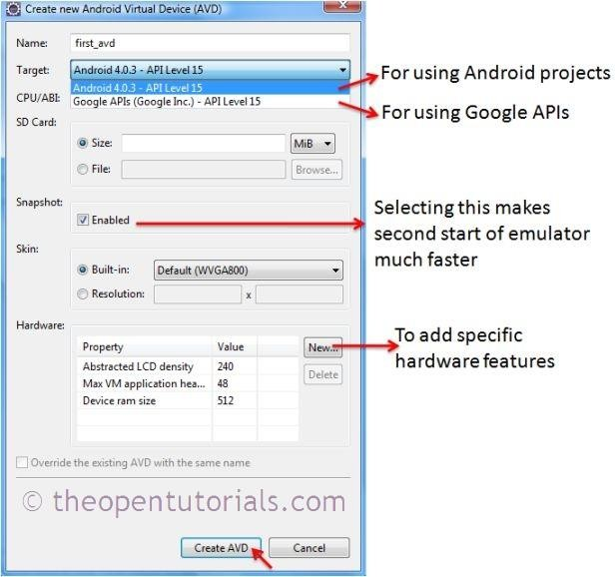
      - Click Create AVD.
Fig: 6.2 AVD dialog

Launch Android AVD (Emulator)
After creating a new Android AVD, you can launch it using “Android AVD Manager”.Open “Android AVD Manager” either from Installation directory or Eclipse
IDE and follow the steps as shown below:
Fig: 6.3 Launch Android AVD (Emulator)
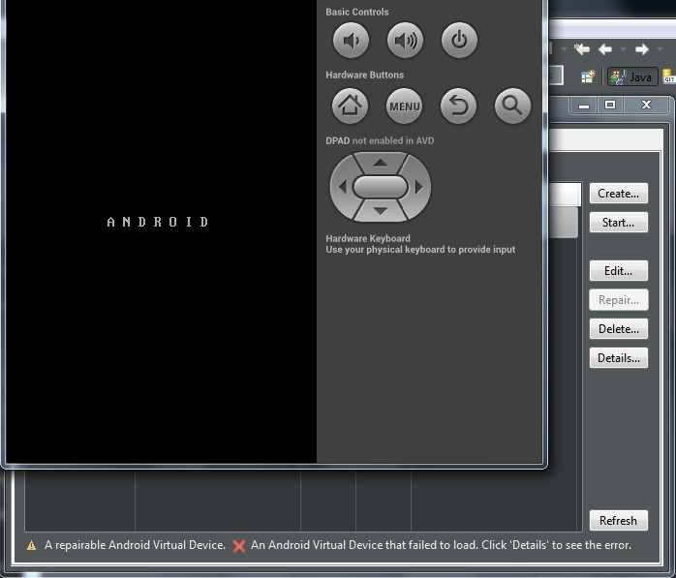
After launching we will get the following screen
Fig 6.4: Emulator screen

6.3 TEST CASES

Test case 1:

 | Test case ID | User view
1. | Precondition | - Open the home screen  - Click button
2. | Description | User open any module
3. | Test Steps | - Click the Health Tips  - Select the treatment
4. | Expected Output | Treatment, Prevention, Precaution will be shown to the user.
5. | Actual Output | Treatment, Prevention, Precaution will be shown to the user.

Table 6.1 : Test case 1
Test case 2:
 | Test case ID | DOCTOR LOGIN
1. | Precondition | - Enter email  - It will be available already
2. | Description | In that doctor find the details of the patient based on the OP booking dates.
3. | Test Steps | - Enter email  - Select Date  - Click get details button
4. | Expected Output | It shows the list of patients who booked an Op at that particular date.
6. | Actual Output | Displays the list of patients who booked an Op at that particular date.
7. | Status | Pass
8. | Remarks

Table 6.2: Test Case 2

7. RESULTS
7.1Execution Procedure
Procedure:
- User Open the app.
- User can book an OP at particular Hospital
- User can look into health tips.
- User can find the doctor base on OP fee.
- User can scan the prescription which was given to him by the doctor.
- If the user is a doctor, he can login into the app and can find the patients who booked an OP at particular date and time.

Screen Shots:

HOME PAGE

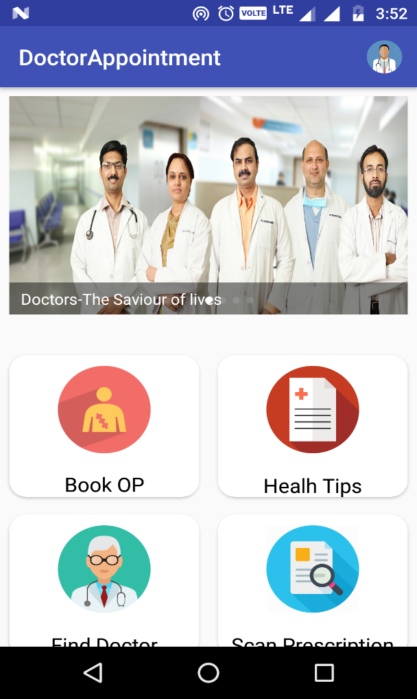
fig 7.1 Home page
Description:
The USER can open the app and can choose the modules he want either it may be booking an OP or finding the doctor base on fee or can look for health tips or for scanning the prescription.

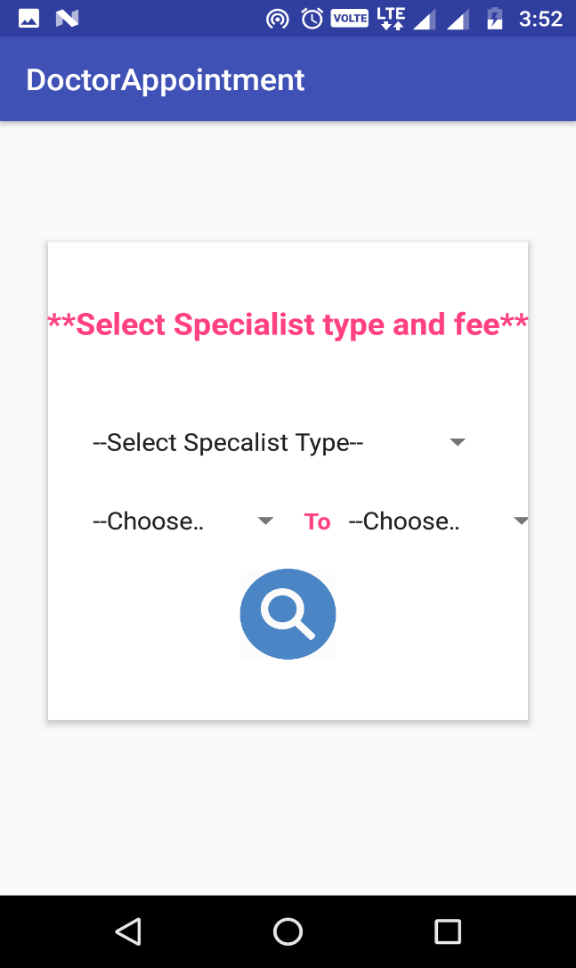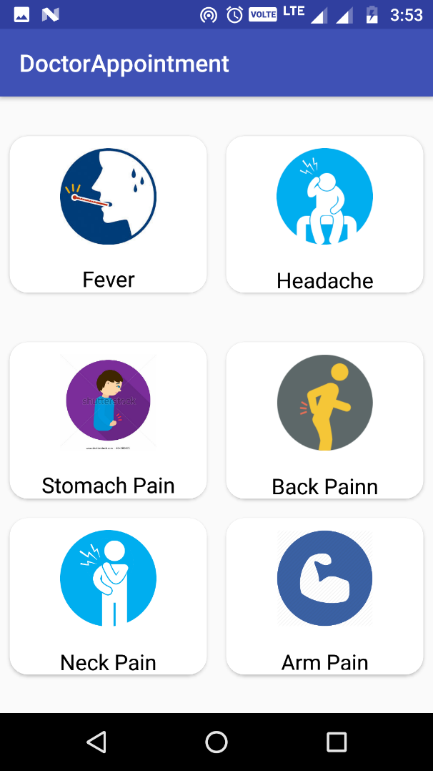
Fig 7.2 Find doctor and Health Tips
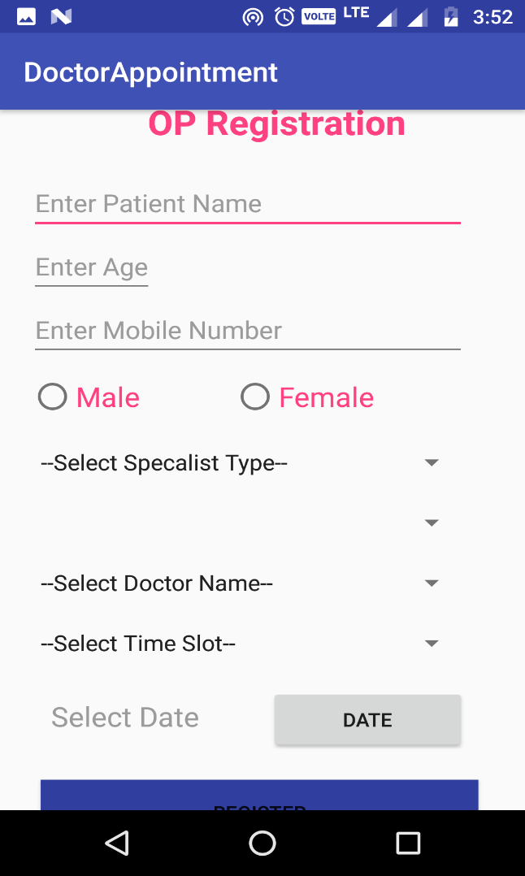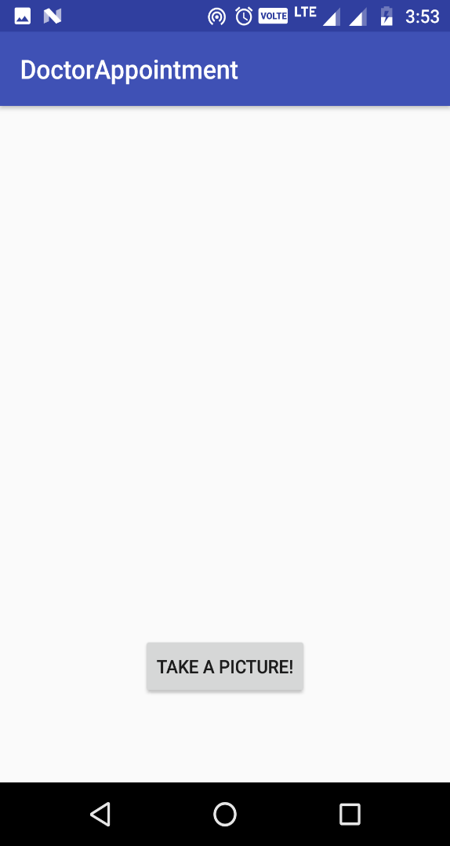
Fig 7.3: OP Registration and Scan prescription

Doctor Login:

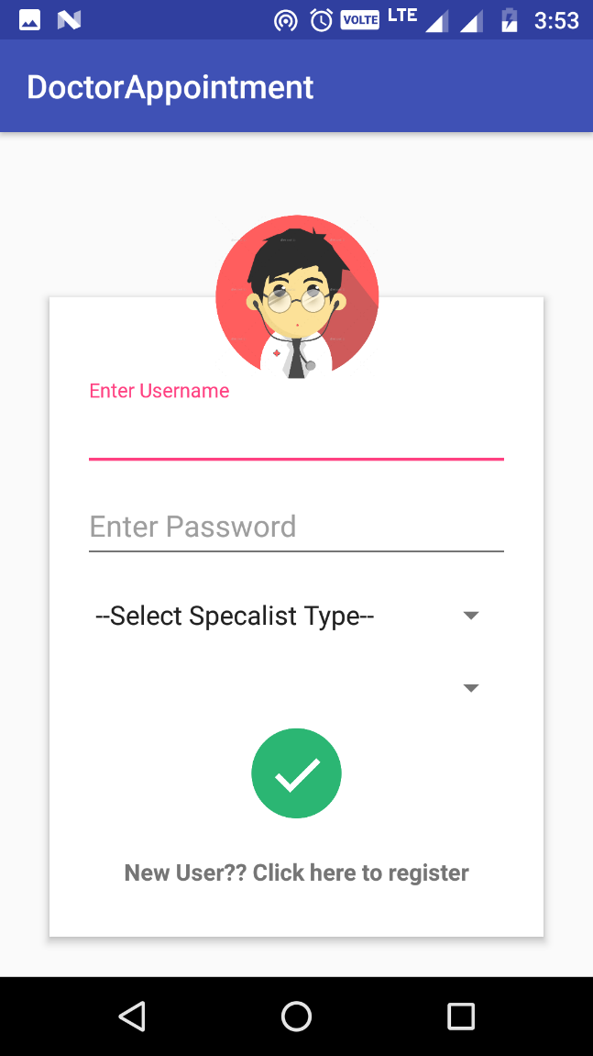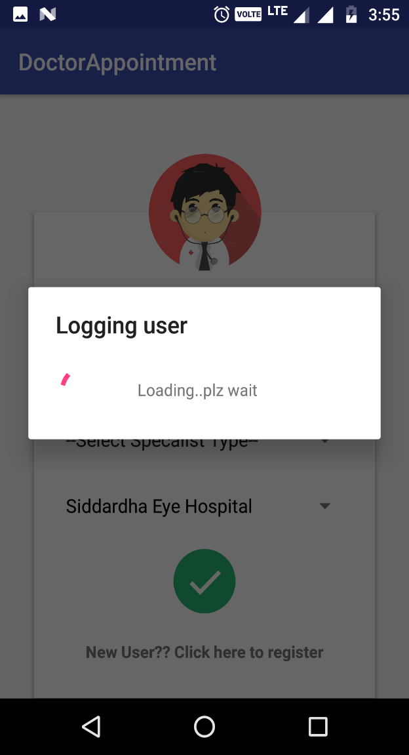
Fig.7.4: Doctor Login
Description:
This page will takes the doctor to his home screen where he can find the patients who booked OP in his hospital.
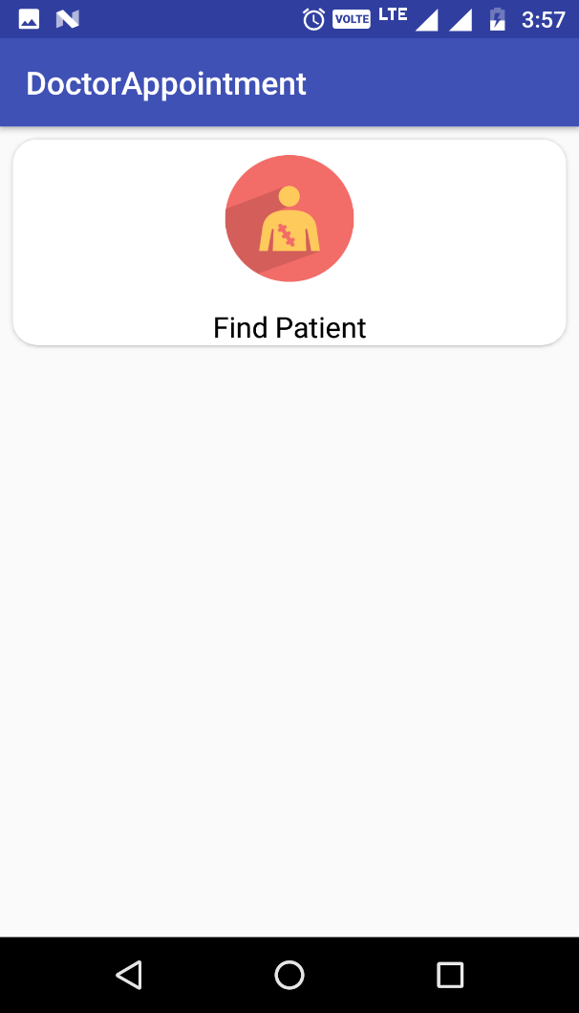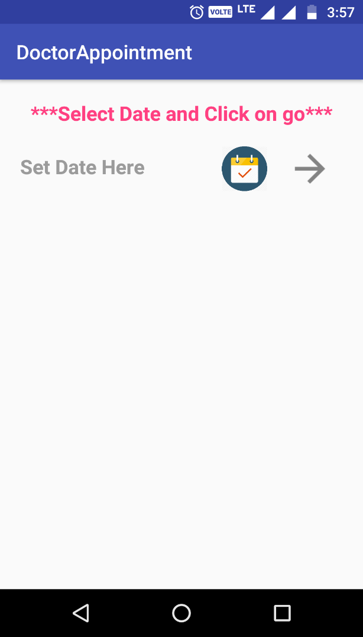
Fig.7.5: Doctor Home
Description:
This page will helps the doctor to find the patients based on their OP booking date.
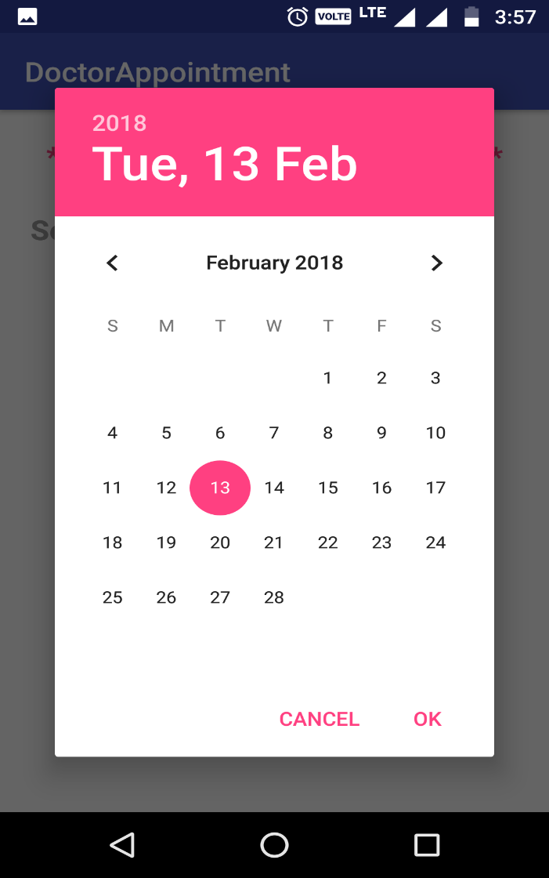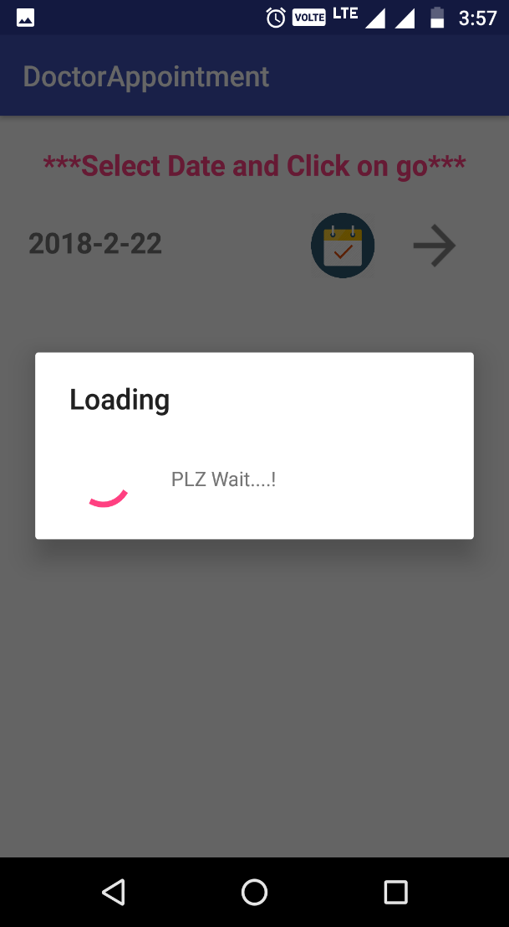
Fig.7.56:Checking for patients
Description:
This page will helps the doctor to load the patients data based on their OP booking date.
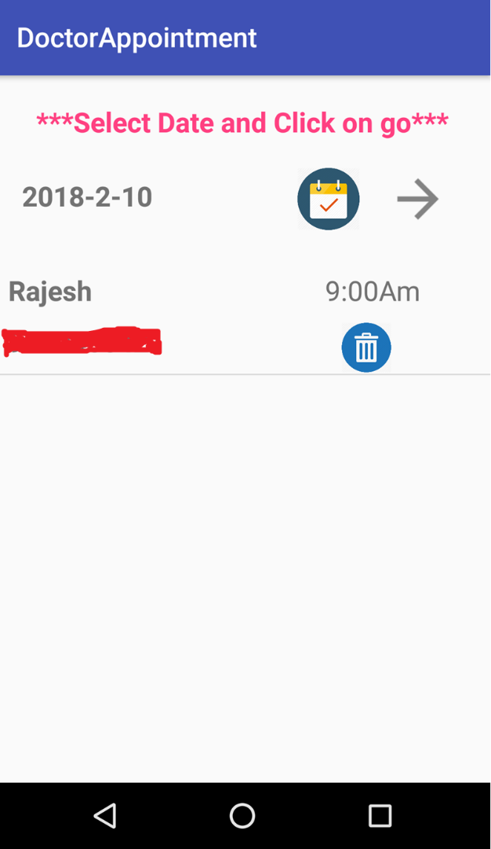
Fig.7.7: Displaying patients Data

8. CONCLUSION AND FUTURE ENHANCEMENT

Conclusion
The completion of this project we are providing the entire Tirupati information using android application. The Smart Info TirupatiAndroid project aims for the user satisfaction in searching about the city and providing more flexibility to the user.

Future Enhancement
The appliction plans to enable online admission process through application i.e., mysql.The entire admission process must be done through mobile.

9. BIBLIOGRAPHY

References
    - ai2.appinventor.mit.edu/

    - ppinventor.mit.edu/explore/tutorial-version/app-inventor-2.html

    - http://www.apssdc.org/

    - http://beta.appinventor.mit.edu/learn/reference/other/activitystarter.html

    - http://puravidaapps.com/

    - appinventor.mit.edu/explore/ai2/beginner-videos.html

    - appinventor – YouTube

    - https://www.youtube.com/user/appinventor

Website

    - www.android.com

    - www.android/playstore.com
s

Text books

    - ‘Behind the Ballot Box: A Citizen's Guide to Voting Systems’ by Douglas J.Amy.
    - ‘App Development &Programming Guide ‘by Samuel Shields.

